Nama : Danang Aji Nugroho

NIM : L200180015

A

PERCOBAAN 1

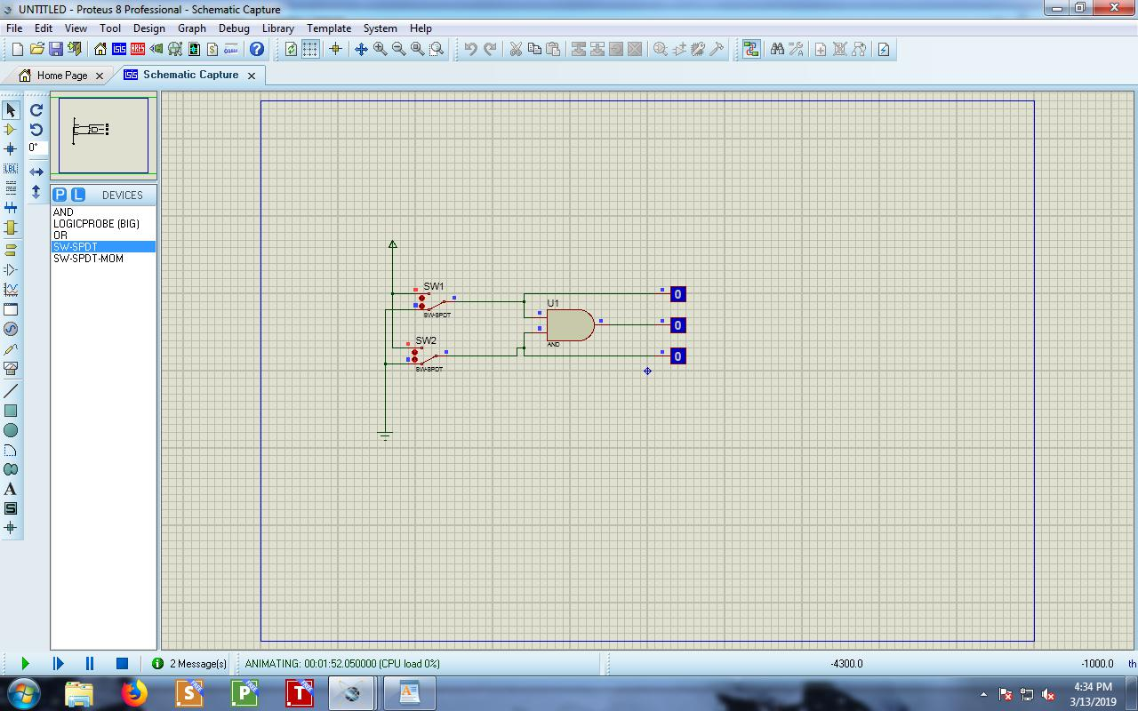

Tabel Kebenaran

|  |  |  |  |  |  |  |  |  |  |  |  |  |  |  |  |
| --- | --- | --- | --- | --- | --- | --- | --- | --- | --- | --- | --- | --- | --- | --- | --- |
|  |  |  | SW1 | SW2 | | L1 | | |  | L2 | | L3 | | |  |
|  |  |  |  |  |  |  |  |  |  |  |  |  |  | |  |
| 0 |  |  |  | 0 |  | 0 |  |  | 0 | |  | 0 |  |  |
|  |  |  |  |  |  |  |  |  |  |  |  |  |  | |  |
| 1 |  |  |  | 0 |  | 1 |  |  | 0 | |  | 0 |  |  |
|  |  |  |  |  |  |  |  |  |  |  |  |  |  | |  |
| 0 |  |  |  | 1 |  | 0 |  |  | 1 | |  | 0 |  |  |
|  |  |  |  |  |  |  |  |  |  |  |  |  |  | |  |
| 1 |  |  |  | 1 |  | 1 |  |  | 1 | |  | 1 |  |  |
|  |  |  |  |  |  |  |  |  |  |  |  |  |  | |  |
| Diagram Waktu | | | |  |  |  |  |  |  |  |  |  |  | |  |
|  |  |  |  |  |  |  |  |  |  |  |  |  |  | |  |
|  |  |  |  |  |  |  |  |  |  |  |  |  |  | |  |
| L1 | |  |  |  |  |  |  |  |  |  |  |  |  |  |
|  |  |  |  |  |  |  |  |  |  |  |  |  |  | |  |
|  |  |  |  |  |  |  |  |  |  |  |  |  |  | |  |
| L2 | |  |  |  |  |  |  |  |  |  |  |  |  |  |
|  |  |  |  |  |  |  |  |  |  |  |  |  |  | |  |
|  |  |  |  |  |  |  |  |  |  |  |  |  |  | |  |
|  |  |  |  |  |  |  |  |  |  |  |  |  |  | |  |





L3

Percobaan 2

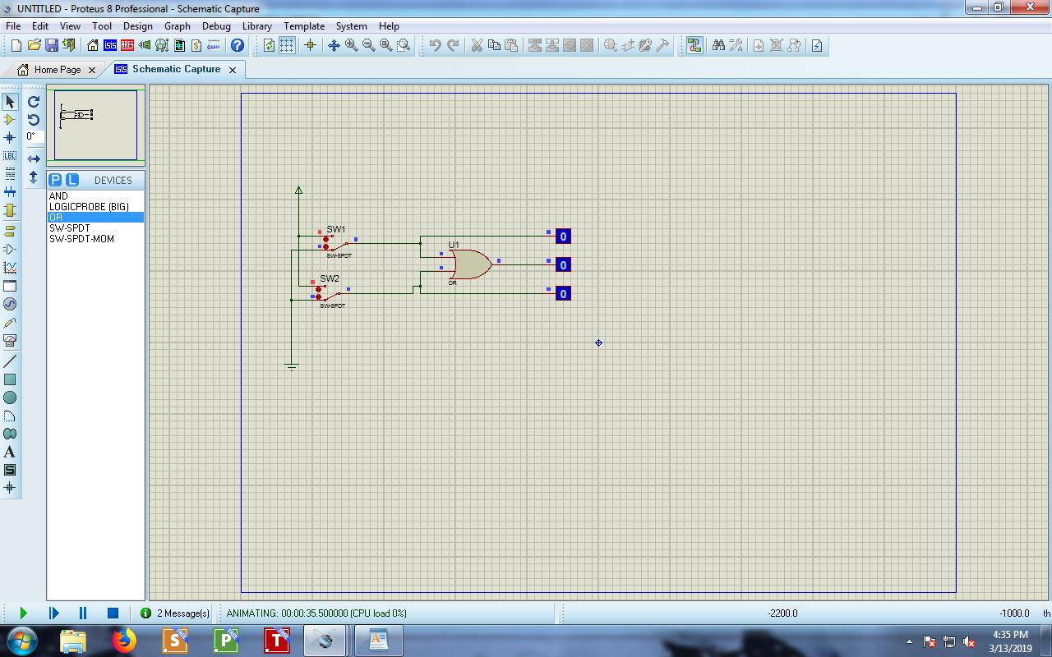

Tabel

Tabel Kebenaran

|  |  |  |  |  |
| --- | --- | --- | --- | --- |
| SW1 | SW2 | L1 | L2 | L3 |
|  |  |  |  |  |
| 0 | 0 | 0 | 0 | 0 |
|  |  |  |  |  |

|  |  |  |  |  |  |  |  |  |
| --- | --- | --- | --- | --- | --- | --- | --- | --- |
| 1 |  | 0 | 1 | 0 | | 1 |  |  |
|  |  |  |  |  |  |  |  |  |
| 0 |  | 1 | 0 | 1 | | 1 |  |  |
|  |  |  |  |  |  |  |  |  |
| 1 |  | 1 | 1 | 1 | | 1 |  |  |
|  |  |  |  |  |  |  |  |  |
| Diagram Waktu | |  |  |  |  |  |  |  |
|  |  |  |  |  |  |  |  |  |
|  |  |  |  |  |  |  |  |  |
| L1 |  |  |  |  |  |  |  |  |
|  |  |  |  |  |  |  |  |  |
|  |  |  |  |  |  |  |  |  |
| L2 |  |  |  |  |  |  |  |  |
|  |  |  |  |  |  |  |  |
|  |  |  |  |  |  |  |  |  |
|  |  |  |  |  |  |  |  |  |
|  |  |  |  |  |  |  |  |  |
| L3 |  |  |  |  |  |  |  |  |
|  |  |  |  |  |  |  |  |
|  |  |  |  |  |  |  |  |  |
| PERCOBAAN 3 | |  |  |  |  |  |  |  |



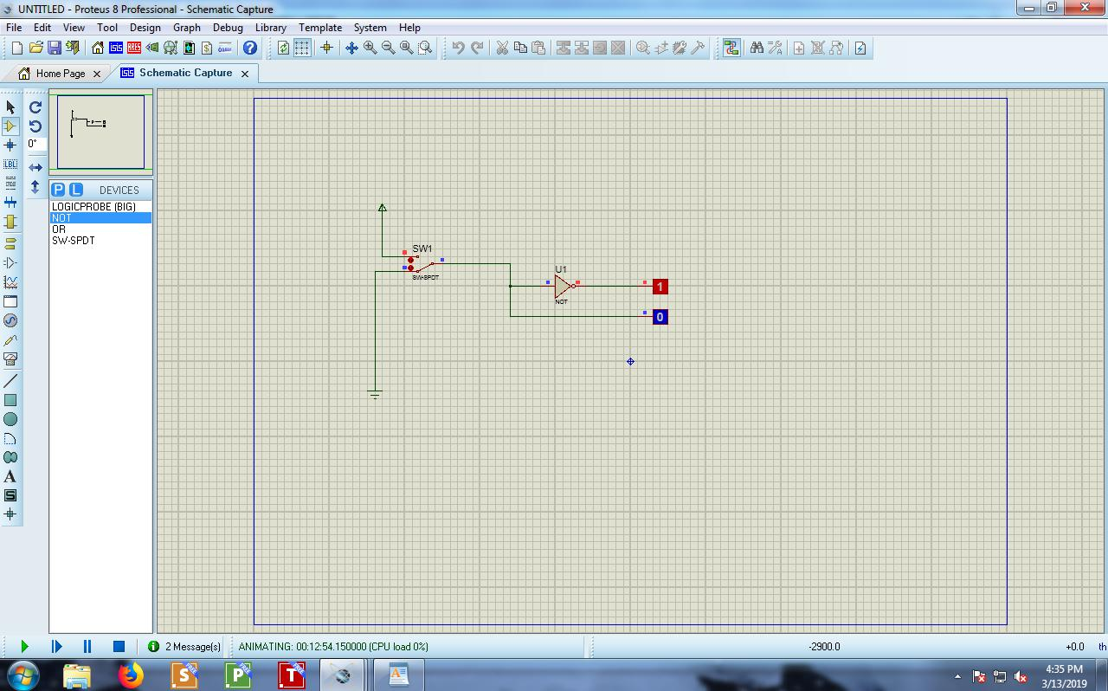 Tabel

Tabel Kebenaran

|  |  |  |
| --- | --- | --- |
| SW1 | L2 | L1 |
|  |  |  |

|  |  |  |
| --- | --- | --- |
| 0 | 0 | 1 |
|  |  |  |
| 1 | 1 | 0 |
|  |  |  |

Diagram Waktu

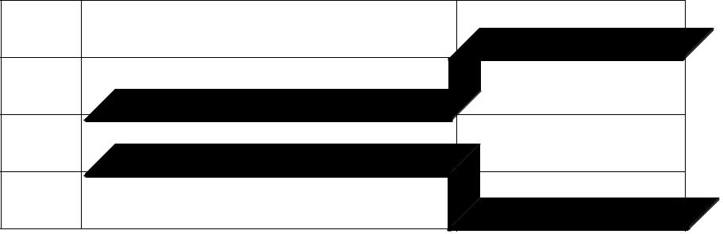

L2

L1

PERCOBAAN 4

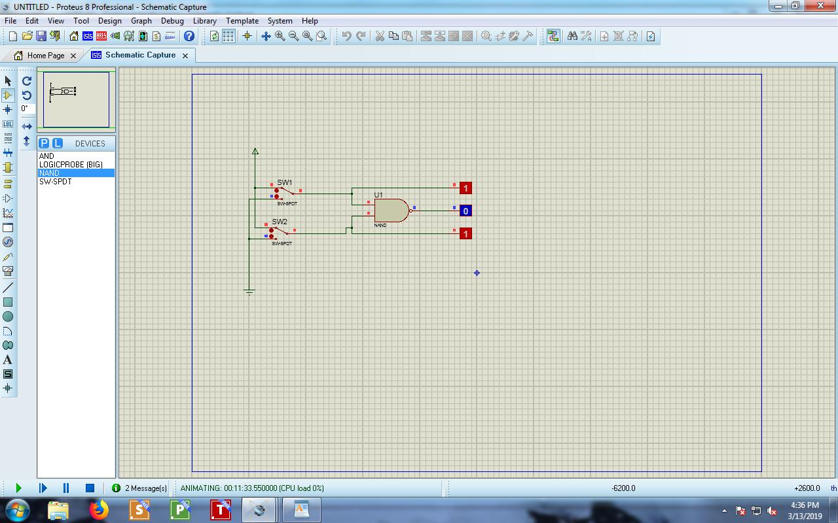

Tabel Kebenaran

|  |  |  |  |  |
| --- | --- | --- | --- | --- |
| SW1 | SW2 | L1 | L2 | L3 |
|  |  |  |  |  |
| 0 | 0 | 0 | 0 | 1 |
|  |  |  |  |  |
| 1 | 0 | 1 | 0 | 1 |
|  |  |  |  |  |
| 0 | 1 | 0 | 1 | 1 |
|  |  |  |  |  |

|  |  |  |  |  |
| --- | --- | --- | --- | --- |
| 1 | 1 | 1 | 1 | 0 |
|  |  |  |  |  |
| Diagram Waktu |  |  |  |  |

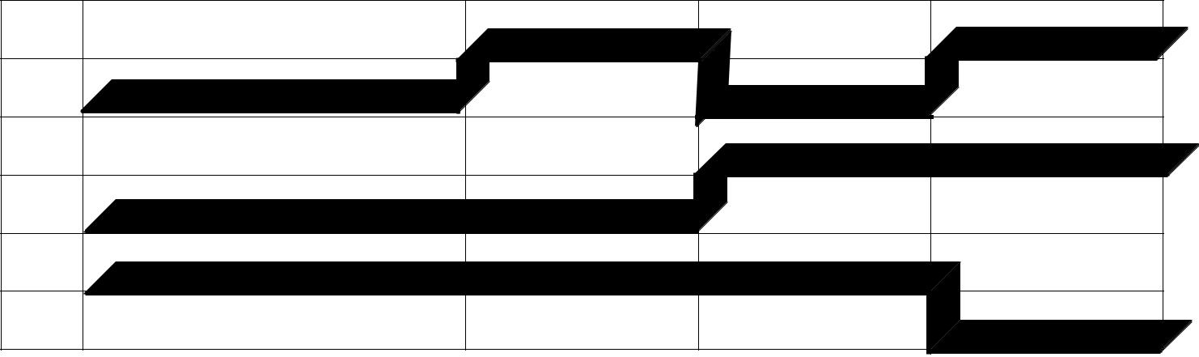

L1

L2

L3

PERCOBAAN 5

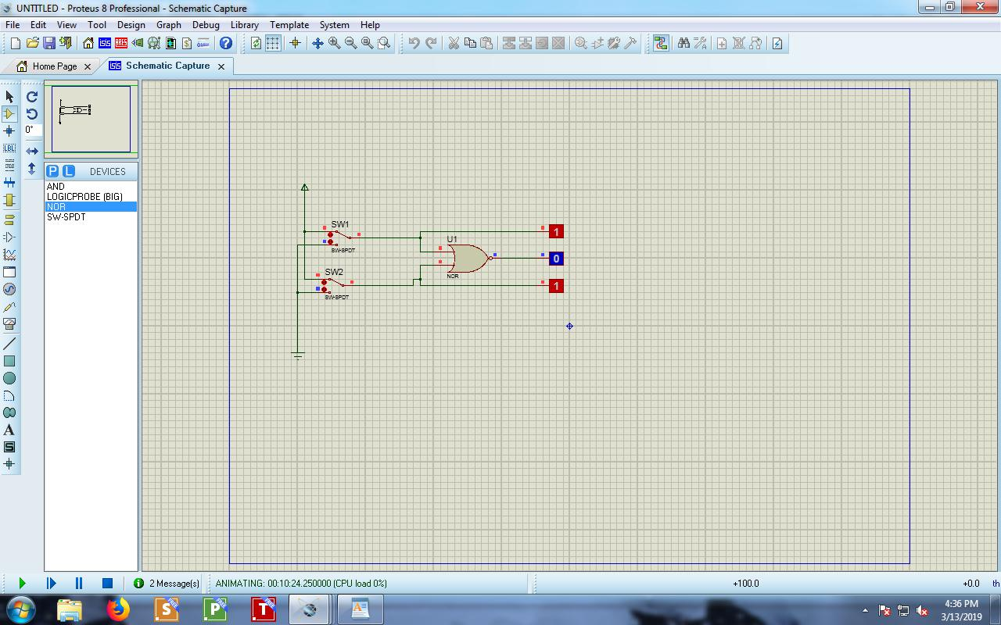

Tabel Kebenaran

|  |  |  |  |  |
| --- | --- | --- | --- | --- |
| SW1 | SW2 | L1 | L2 | L3 |
|  |  |  |  |  |
| 0 | 0 | 0 | 0 | 1 |
|  |  |  |  |  |
| 1 | 0 | 1 | 0 | 0 |
|  |  |  |  |  |

|  |  |  |  |  |
| --- | --- | --- | --- | --- |
| 0 | 1 | 0 | 1 | 0 |
|  |  |  |  |  |
| 1 | 1 | 1 | 1 | 0 |
|  |  |  |  |  |

Diagram Waktu

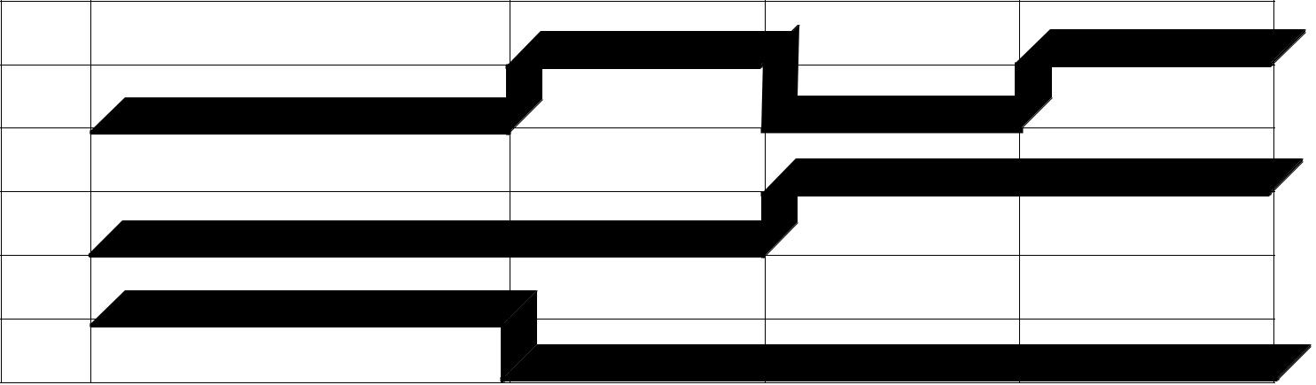

L1

L2

L3

PERCOBAAN 6

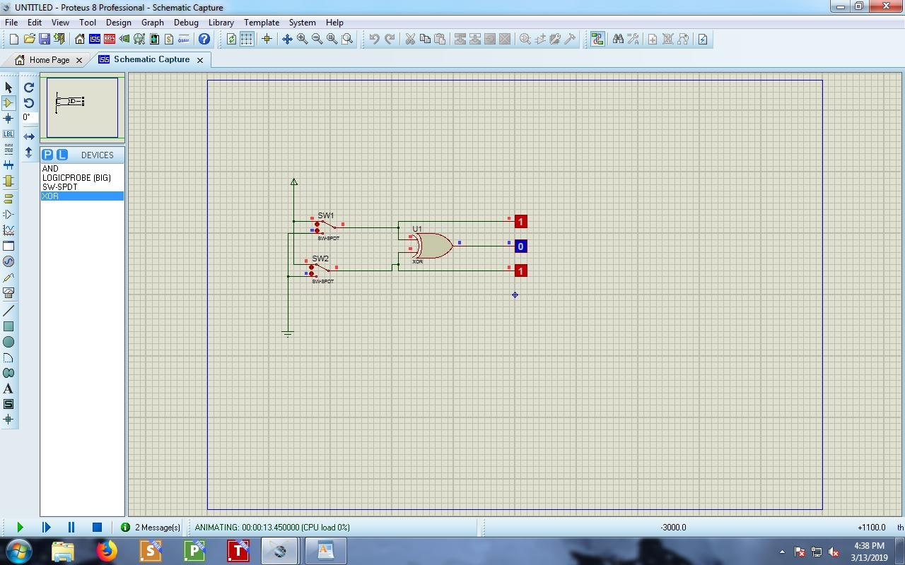

Tabel Kebenaran

|  |  |  |  |  |
| --- | --- | --- | --- | --- |
| SW1 | SW2 | L1 | L2 | L3 |
|  |  |  |  |  |
| 0 | 0 | 0 | 0 | 0 |
|  |  |  |  |  |

|  |  |  |  |  |  |  |  |  |  |  |
| --- | --- | --- | --- | --- | --- | --- | --- | --- | --- | --- |
| 1 |  |  | 0 |  | 1 | 0 |  | 1 |  |  |
|  |  |  |  |  |  |  |  |  |  |  |
| 0 |  |  | 1 |  | 0 | 1 |  | 1 |  |  |
|  |  |  |  |  |  |  |  |  |  |  |
| 1 |  |  | 1 |  | 1 | 1 |  | 0 |  |  |
|  |  |  |  |  |  |  |  |  |  |  |
| Diagram Waktu | | |  |  |  |  |  |  |  |  |
|  |  |  |  |  |  |  |  |  |  |  |
|  |  |  |  |  |  |  |  |  |  |  |
| L1 | |  |  |  |  |  |  |  |  |  |
|  |  |  |  |  |  |  |  |  |  |  |
|  |  |  |  |  |  |  |  |  |  |  |
|  |  |  |  |  |  |  |  |  |  |  |
| L2 | |  |  |  |  |  |  |  |  |  |
|  |  |  |  |  |  |  |  |  |
|  |  |  |  |  |  |  |  |  |  |  |
|  |  |  |  |  |  |  |  |  |  |  |
| L3 | |  |  |  |  |  |  |  |  |  |
|  |  |  |  |  |  |  |  |  |
|  |  |  |  |  |  |  |  |  |  |  |



PERCOBAAN 7

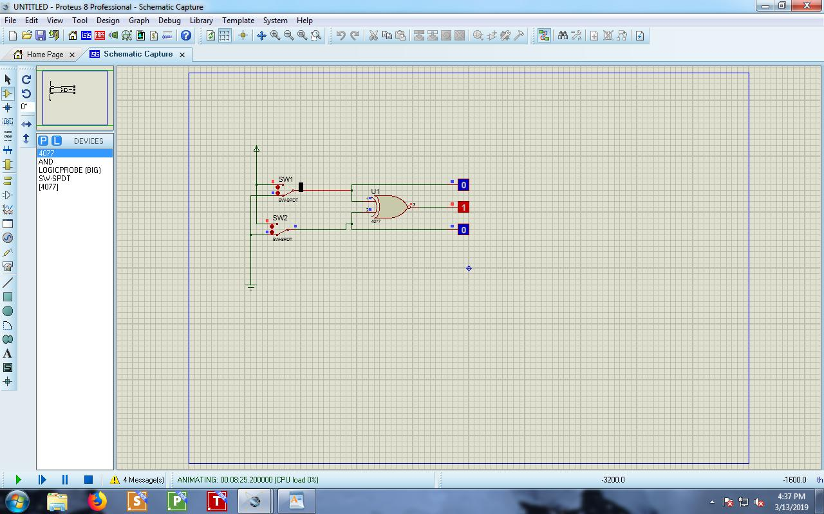

Tabel Kebenaran

|  |  |  |  |  |  |  |  |  |  |  |  |
| --- | --- | --- | --- | --- | --- | --- | --- | --- | --- | --- | --- |
|  |  |  | SW1 | SW2 | | L1 |  | L2 | | L3 | |
|  |  |  |  |  |  |  |  |  |  |  |  |
| 0 |  |  |  | 0 |  | 0 | 0 | |  | 1 |  |
|  |  |  |  |  |  |  |  |  |  |  |  |
| 1 |  |  |  | 0 |  | 1 | 0 | |  | 0 |  |
|  |  |  |  |  |  |  |  |  |  |  |  |
| 0 |  |  |  | 1 |  | 0 | 1 | |  | 0 |  |
|  |  |  |  |  |  |  |  |  |  |  |  |
| 1 |  |  |  | 1 |  | 1 | 1 | |  | 1 |  |
|  |  |  |  |  |  |  |  |  |  |  |  |
| Diagram Waktu | | | |  |  |  |  |  |  |  |  |
|  |  |  |  |  |  |  |  |  |  |  |  |
|  |  |  |  |  |  |  |  |  |  |  |  |
| L1 | | |  |  |  |  |  |  |  |  |  |
|  |  |  |  |  |  |  |  |  |  |  |  |
|  |  |  |  |  |  |  |  |  |  |  |  |
| L2 | | |  |  |  |  |  |  |  |  |  |
|  |  |  |  |  |  |  |  |  |  |  |  |
|  |  |  |  |  |  |  |  |  |  |  |  |
|  | | |  |  |  |  |  |  |  |  |  |
| L3 |  | |  |  |  |  |  |  |  |  |  |
|  |  |  |  |  |  |  |  |  |  |  |  |

